Lab – Managing Router Configuration Files with Terminal Emulation Software
Topology
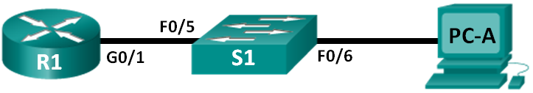
Addressing Table
Device | Interface | IP Address | Subnet Mask | Default Gateway
R1 | G0/1 | 192.168.1.1 | 255.255.255.0 | N/A
S1 | VLAN 1 | 192.168.1.11 | 255.255.255.0 | 192.168.1.1
PC-A | NIC | 192.168.1.3 | 255.255.255.0 | 192.168.1.1
Objectives
Part 1: Configure Basic Device Settings
Part 2: Use Terminal Emulation Software to Create a Backup Configuration File
Part 3: Use a Backup Configuration File to Restore a Router
Background / Scenario
It is a recommended best practice to maintain backup configuration files for routers and switches in the event that they need to be restored to a previous configuration. Terminal emulation software can be used to easily back up or restore a router or switch configuration file.
In this lab, you will use Tera Term to back up a router running configuration file, erase the router startup configuration file, reload the router, and then restore the missing router configuration from the backup configuration file.
Note: The routers used with CCNA hands-on labs are Cisco 1941 Integrated Services Routers (ISRs) with Cisco IOS Release 15.2(4)M3 (universalk9 image). The switches used are Cisco Catalyst 2960s with Cisco IOS Release 15.0(2) (lanbasek9 image). Other routers, switches, and Cisco IOS versions can be used. Depending on the model and Cisco IOS version, the commands available and output produced might vary from what is shown in the labs. Refer to the Router Interface Summary Table at the end of this lab for the correct interface identifiers.
Note: Make sure that the routers and switches have been erased and have no startup configurations. If you are unsure, contact your instructor.
Required Resources
- 1 Router (Cisco 1941 with Cisco IOS Release 15.2(4)M3 universal image or comparable)
- 1 Switch (Cisco 2960 with Cisco IOS Release 15.0(2) lanbasek9 image or comparable)
- 1 PC (Windows 7, Vista, or XP with terminal emulation program, such as Tera Term)
- Console cables to configure the Cisco IOS devices via the console ports
- Ethernet cables as shown in the topology
- Configure Basic Device Settings
In Part 1, you will set up the network topology and configure basic settings, such as the interface IP addresses, device access, and passwords on the router.
  - Cable the network as shown in the topology.
Attach the devices as shown in the topology and cable as necessary.
  - Configure the PC-A network settings according to the Addressing Table.
  - Initialize and reload the router and switch.
  - Configure the router.
    - Console into the router and enter global configuration mode.
    - Copy the following basic configuration and paste it to the running-configuration on R1.
no ip domain-lookup
hostname R1
service password-encryption
enable secret class
banner motd #
Unauthorized access is strictly prohibited. #
Line con 0
password cisco
login
logging synchronous
line vty 0 4
password cisco
login
    - Configure and activate the G0/1 interface on the router using the information contained in the Addressing Table.
    - Save the running configuration to the startup configuration file.
  - Configure the switch.
    - Console into the switch and enter into global configuration mode.
    - Copy the following basic configuration and paste it to the running-configuration on S1.
no ip domain-lookup
hostname S1
service password-encryption
enable secret class
banner motd #
Unauthorized access is strictly prohibited. #
Line con 0
password cisco
login
logging synchronous
line vty 0 15
password cisco
login
exit
    - Configure the default SVI management interface with the IP address information contained in the Addressing Table.
    - Configure the switch default gateway.
    - Save the running configuration to the startup configuration file.
- Use Terminal Emulation Software to Create a Backup Configuration File
  - Establish a Tera Term console session to the router.
Launch the Tera Term Program, and in the New Connection window, select the Serial radio button and the appropriate communications port for your PC (i.e., COM1).
Note: If Tera Term is not installed, you can download the latest version from a number of Internet sites. Simply search for a Tera Term download.
    - In Tera Term, press Enter to connect to the router.
    - From the File menu, choose Log…, and save the teraterm.log file to the Desktop. Ensure that the Append and Plain text check boxes are enabled (checked).
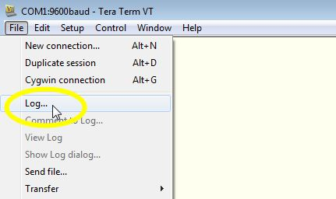
    - The Tera Term log file will create a record of every command issued and every output displayed.
Note: You can use this feature to capture the output from several commands in sequence and use it for network documentation purposes. For example, you could issue the show version, show ip interface brief, and show running-config commands to capture information about the router.
  - Display the router running-configuration.
    - Use the console password to log in to the router.
    - Enter privileged EXEC mode.
    - Enter the show running-config command.
    - Continue pressing the space bar when --More-- is displayed until you see the router R1# prompt return.
    - Click the Tera Term: Log icon on the Task bar. Click Close to end log session.
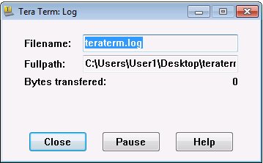
Note: You can also copy and paste the text from the Tera Term window directly into a text editor.
- Use a Backup Configuration File to Restore a Router
  - Erase the router startup-configuration and reload.
    - From privileged EXEC mode erase the startup configuration.
R1# erase startup-config
Erasing the nvram filesystem will remove all configuration files! Continue? [confirm]
[OK]
Erase of nvram: complete
    - Reload the router.
R1# reload
Proceed with reload? [confirm]
    - At the System Configuration Dialog prompt, type no; a router prompt displays, indicating an unconfigured router.
--- System Configuration Dialog ---

Would you like to enter the initial configuration dialog? [yes/no]:

Press RETURN to get started!
<output omitted>
Router>
    - Enter privileged EXEC mode and enter a show running-config command to verify that all of the previous configurations were erased.
  - Edit the saved configuration backup file to prepare it for restoring the router configuration.
To restore the router configuration from a saved running configuration backup file, you must edit the text.
    - Open the teraterm.log text file.
    - Remove each instance of --More-- in the text file.
Note: The --More-- was generated by pressing the Spacebar when displaying the running configuration.
    - Delete the initial lines of the backup configuration file, so that the first line starts with the first configuration command as shown below.
service timestamps debug datetime msec
service timestamps log datetime msec
service password-encryption
    - In the lines for interface GigabitEthernet0/1, insert a new line to enable the interface.
interface GigabitEthernet0/1
ip address 192.168.1.1 255.255.255.0
duplex auto
speed auto
Change to:
interface GigabitEthernet0/1
ip address 192.168.1.1 255.255.255.0
duplex auto
speed auto
no shutdown
    - After you have made all of the edits to the backup configuration file, save your changes to filename R1-config-backup.
Note: When saving the file, an extension such as .txt, may be added to the filename automatically.
  - Restore the router configuration.
You can restore the edited running configuration directly to the console terminal in router global configuration mode, and the configurations are entered as if they were commands entered individually at the command prompt.
    - From the Tera Term console connection to the router, enter global configuration mode.
    - From the File menu, select Send file….
    - Locate R1-config-backup and select Open.
    - Save the running configuration to the startup configuration file.
R1# copy running-config startup-config
    - Verify the new running configuration.
  - Back up and restore the switch.
Go back to the beginning of Part 2 and follow the same steps to backup and restore the switch configuration.
Reflection
Why do you think it is important to use a text editor instead of a word processor to copy and save your command configurations?
_______________________________________________________________________________________
_______________________________________________________________________________________
_______________________________________________________________________________________
Router Interface Summary Table
Router Interface Summary
Router Model | Ethernet Interface #1 | Ethernet Interface #2 | Serial Interface #1 | Serial Interface #2
1800 | Fast Ethernet 0/0 (F0/0) | Fast Ethernet 0/1 (F0/1) | Serial 0/0/0 (S0/0/0) | Serial 0/0/1 (S0/0/1)
1900 | Gigabit Ethernet 0/0 (G0/0) | Gigabit Ethernet 0/1 (G0/1) | Serial 0/0/0 (S0/0/0) | Serial 0/0/1 (S0/0/1)
2801 | Fast Ethernet 0/0 (F0/0) | Fast Ethernet 0/1 (F0/1) | Serial 0/1/0 (S0/1/0) | Serial 0/1/1 (S0/1/1)
2811 | Fast Ethernet 0/0 (F0/0) | Fast Ethernet 0/1 (F0/1) | Serial 0/0/0 (S0/0/0) | Serial 0/0/1 (S0/0/1)
2900 | Gigabit Ethernet 0/0 (G0/0) | Gigabit Ethernet 0/1 (G0/1) | Serial 0/0/0 (S0/0/0) | Serial 0/0/1 (S0/0/1)
Note: To find out how the router is configured, look at the interfaces to identify the type of router and how many interfaces the router has. There is no way to effectively list all the combinations of configurations for each router class. This table includes identifiers for the possible combinations of Ethernet and Serial interfaces in the device. The table does not include any other type of interface, even though a specific router may contain one. An example of this might be an ISDN BRI interface. The string in parenthesis is the legal abbreviation that can be used in Cisco IOS commands to represent the interface.

