

PEIMS Fall Submission 1

- PEIMS Responsibilities and Requirements
- Verifying PEIMS Data with the DMC
- Promoting PEIMS Data
- Validating PEIMS Data
- Searching PEIMS Data
- Verifying PEIMS Reports
- Preparing/Finalizing PEIMS Data



TSDS PEIMS Fall Submission 1

TSDS PEIMS – Submission Responsibilities & Requirements

The Texas Student Data System (TSDS) is a statewide system for collecting and reporting education data for Texas publicly funded schools.

2024-2025 PEIMS Fall Submission Timeline
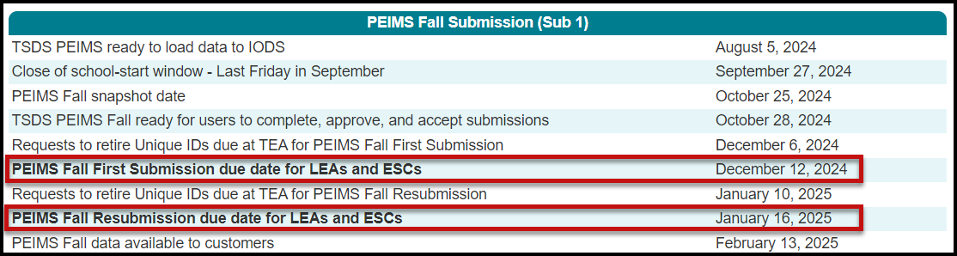

TSDS TWEDS – Texas Education Data Standards

The data submitted through TSDS must be submitted in Ed-Fi format via an API connection as defined in TWEDS (TSDS Web Enabled Data Standards). The TWEDS is located on the TSDS website.

https://tealprod.tea.state.tx.us/TWEDSAPI/23/395/0/Overview

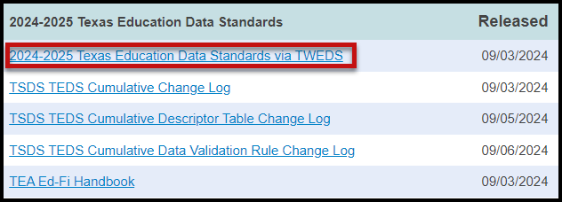

According to TEDS the LEAs (Local Education Agencies) are responsible for:

- Submitting current, complete, and accurate data required for each PEIMS and TSDS Core submission
- Validating data per the business rules and validations
- Correcting all errors during the validation process in a timely manner
- Delivering “fatal-free” corrected PEIMS data on or before any due dates set by the ESC or TEA.

TSDS – PEIMS Access and User Roles

The TSDS PEIMS application is only available to authorized ESC, district, and campus staff. A TEAL logon is required as well as access to the Texas Student Data System Portal. Different roles can be assigned to the user based on the access required. There are several different roles in the PEIMS application, each with a different level of access.
NEW
- DMC LEA Data Monitor w/Map Descriptors Privileges – This role allows the user to monitor the data that has been loaded in the IODS. It allows the user access to L1.5 Filters, Descriptor Mapping, Search Data, and Reports.
NEW
- DMC LEA L2 Validations w/Fall Privileges – This role allows the user to schedule, run, and view L2 Validations (Fatals, Special Warnings, and Warnings) prior to promoting and validating the data in the actual TSDS submission.

- PEIMS Campus Submitter (Campus) – This role allows the user to promote loaded data, validate (prepare) data, search all PEIMS data, and view PEIMS reports for a specific campus.

- PEIMS Data Submitter (LEA) - This role allows the user to promote loaded data, validate (prepare) data, search all PEIMS data, and view PEIMS reports at the district level.

- PEIMS Data Completer (LEA PEIMS Coordinator) – This role allows the user to promote loaded data, validate (prepare) data, complete (finalize) data, search all PEIMS data, and view reports at the district level.

- PEIMS Data Approver (LEA Superintendent) – This role allows the Superintendent to approve the PEIMS data submission and apply for an extension if necessary.

- PEIMS Data Accepter (ESC) - This role allows the user at the ESC to view and run reports, accept, or reject the PEIMS data submission.

Verifying Fall PEIMS Data – Manage IODS in the DMC

The DMC (Data Management Center) allows LEAs to monitor and validate their data in the IODS (Individual Operational Data Store). All data is stored in the IODS prior to promoting it to the individual TSDS or PEIMS collections. Together the systems allow LEAs to synchronize near real time updates via the API between the source systems and their IODS, enable LEAs to perform more rigorous validations early in the submission process, and provide LEAs the ability to search and view data in the IODS.

- Log into TEAL and select Texas Student Data System Portal.
- On the Home screen select Manage IODS.

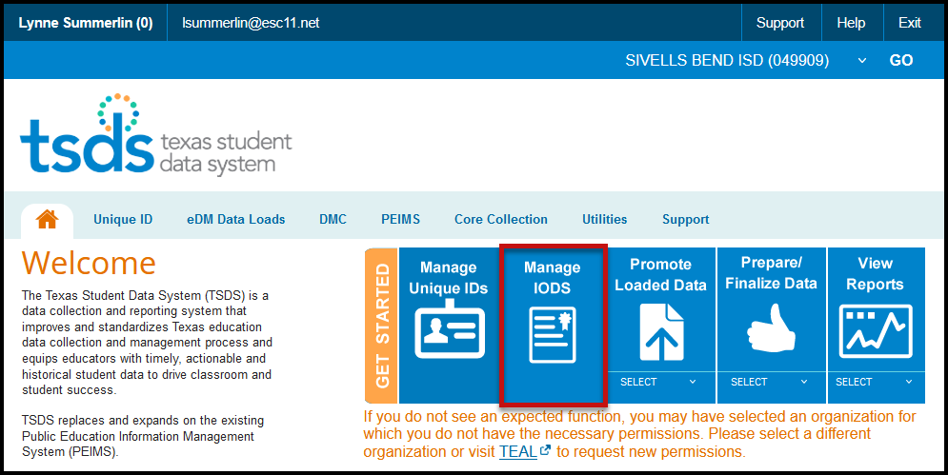

- The Welcome to the DMC screen appears:

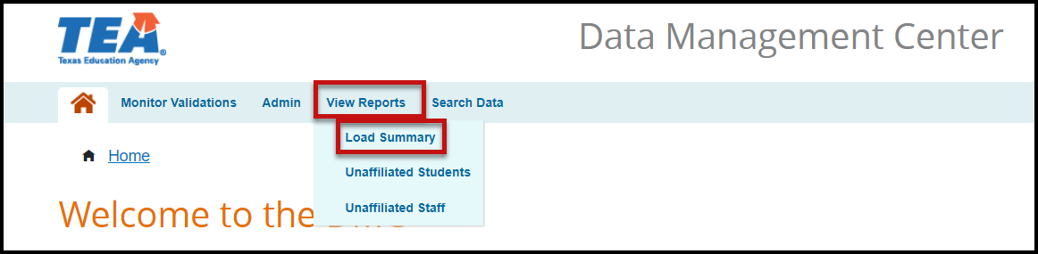

- Under View Reports, select Load Summary. Verify that data has been loaded for the appropriate Domains.

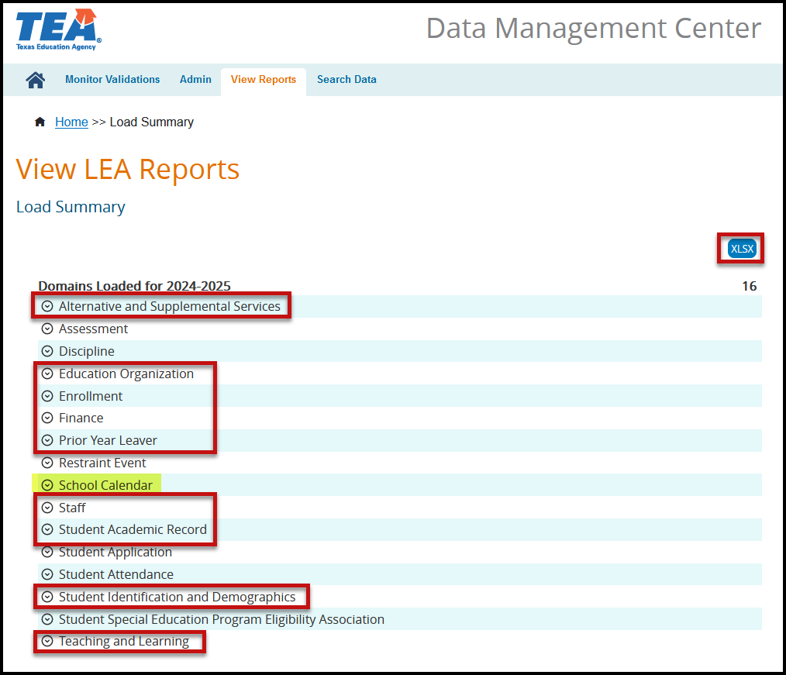

- Click the down arrow icon next to the Domain name to view the number of records loaded and the last date the records were updated. If no records are listed for the entities, the LEA must check to determine why data is not being sent through the API.

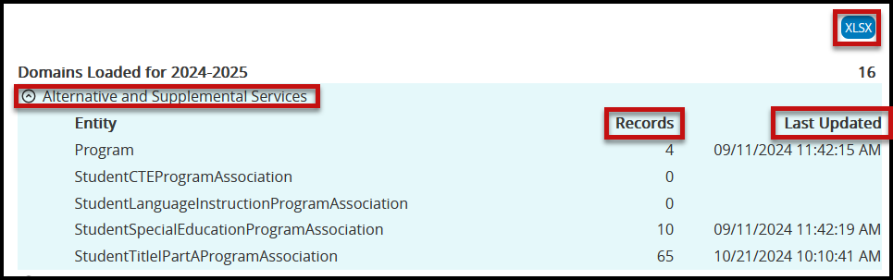

- Click XLSX to download a spreadsheet of the domains, entities, and number of records loaded.

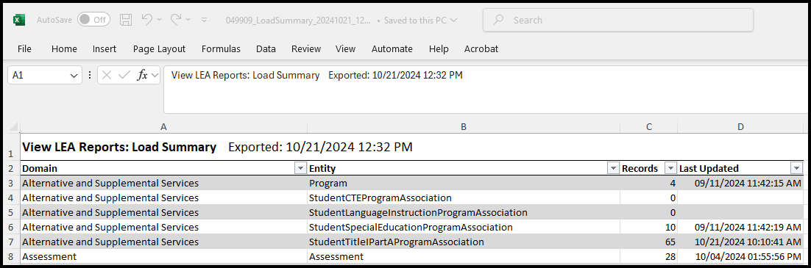

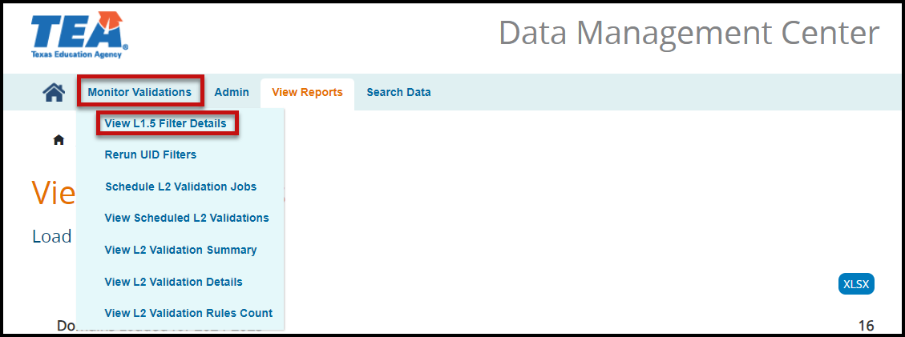

- Under Monitor Validations select View L1.5 Filter Details. The View L1.5 Filter Details screen appears.

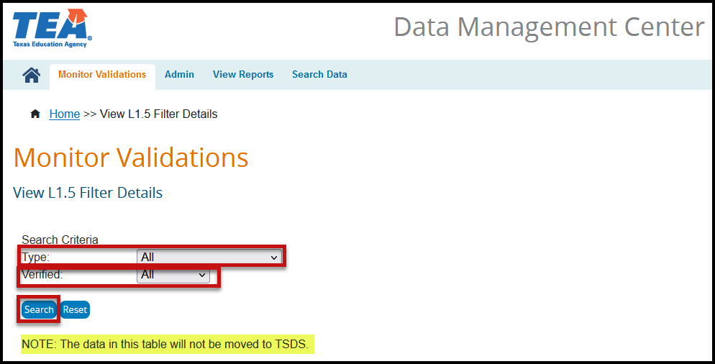

- Select All for the Type under Search Criteria.
- Select All for the Unverified status under Search Criteria.
- Click Search. If there are any L1.5 filters that need to be verified a list will appear. For the CSW collection LEAs will need to verify any L1.5 filters for UID - Student and possibly the Descriptor Values.
- If there are any L1.5 Filters, make any corrections that need to be made in the software, and mark them as verified.

Note: Any data in this table will not be moved to TSDS. L1.5 Filters do not necessarily mean there is an error in your data. L1.5 Filters are just pieces of data that do not meet the requirements for submission to TSDS.

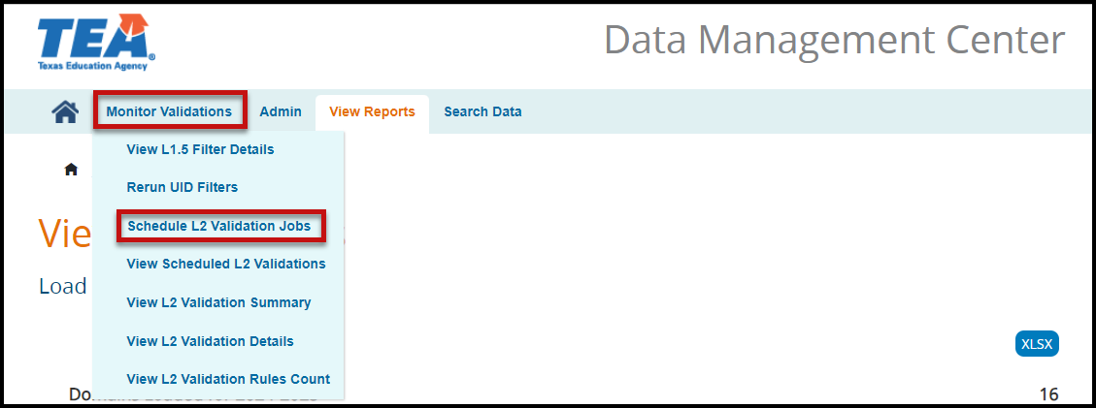

- Under Monitor Validations select Schedule L2 Validation Jobs. The Run L2 Validations screen appears.
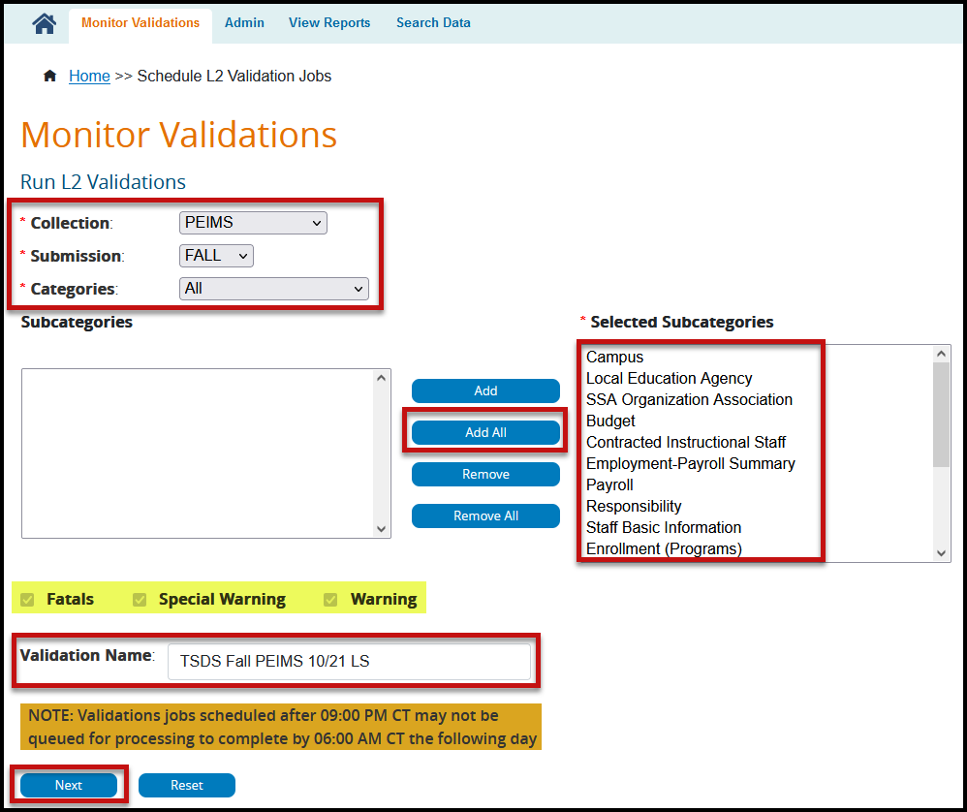

- Select PEIMS from the Collection pull-down menu.
- Select FALL from the Submission pull-down menu.
- Select All from the Categories pull-down menu.
- Move all the Subcategories to the Selected Subcategories by clicking the Add All button.
- Enter a Validation Name.
- Click Next. The Confirm Validation Request screen appears.

Note: The selections for Fatals, Special Warning, and Warning are grayed out. The process will run all three validations.
Validation jobs scheduled after 9:00 PM may not be queued for processing to complete by 6:00 AM the following day.

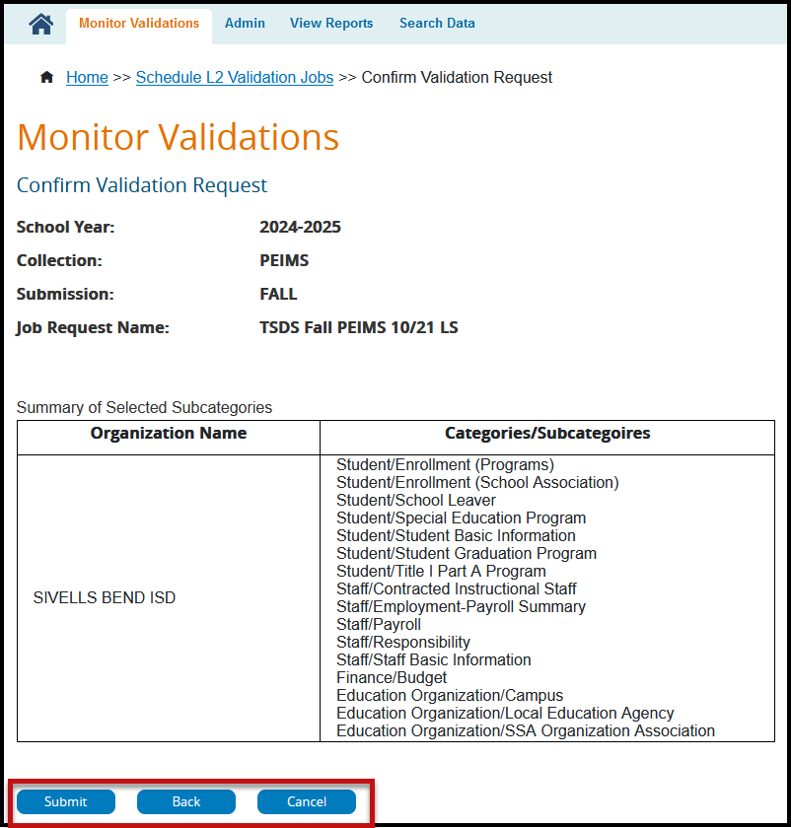

- Verify all the information on the screen is complete.
- Click Submit to continue scheduling the L2 Validations.
- Click Back to return to the previous screen.
- Click Cancel to discontinue the process.

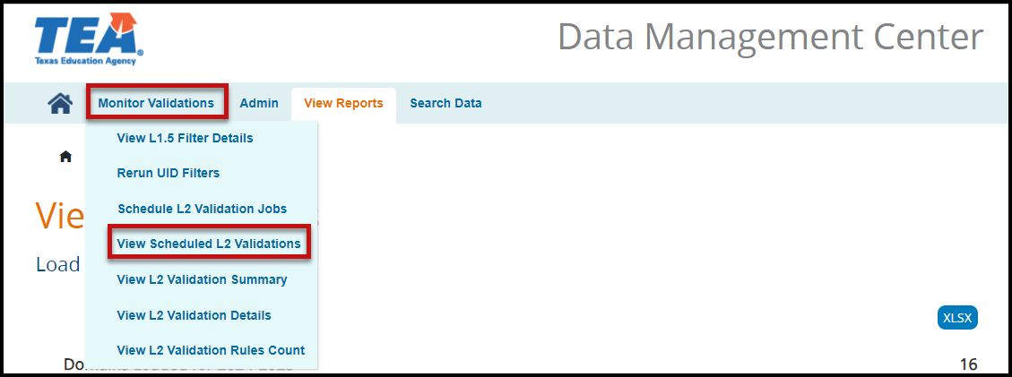

- Under Monitor Validations select View Scheduled L2 Validations to view the progress of the scheduled L2 Validations. The View L2 Validation Requests Summary screen appears.

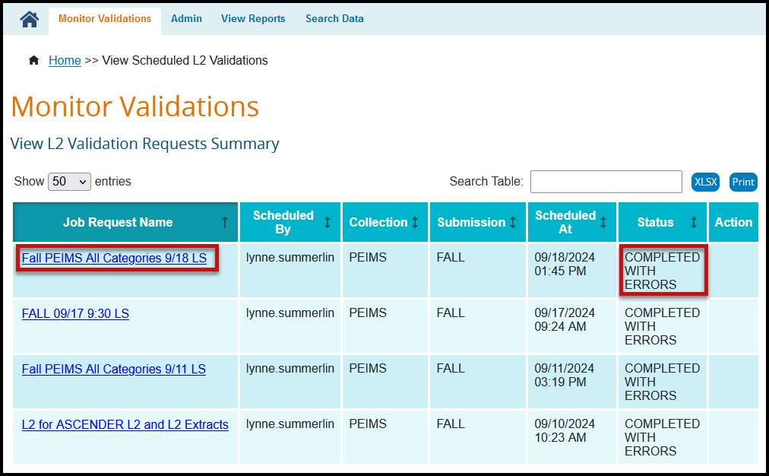

The screen lists the Job Request Name, Scheduled By, Collection, Submission, Scheduled At (DTS), Status, and Action. The columns can be sorted by selecting the arrow icon in the header next to the item to be used for the sort.

- The number of entries shown can be changed using the pull-down menu for Show entries.
- Items on the table can be searched using the Search Table feature.
- The data can be Printed or downloaded as an XLSX.
- Once the status shows Completed or Completed with Errors, click the Job Request Name (hyperlink) to view the number of errors by Category and Subcategory.

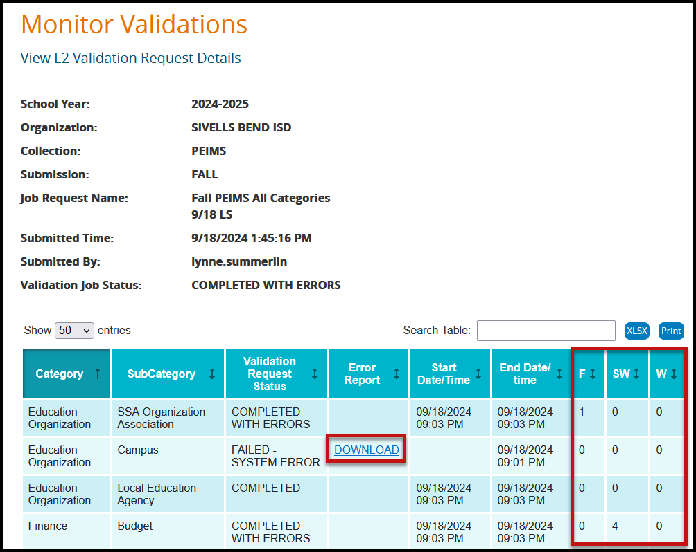

- The number of entries shown can be changed using the pull-down menu for Show entries.
- Items on the table can be searched using the Search Table feature.
- The data can be Printed or downloaded as an XLSX.
- Error Reports can be viewed by selecting the Download hyperlink.

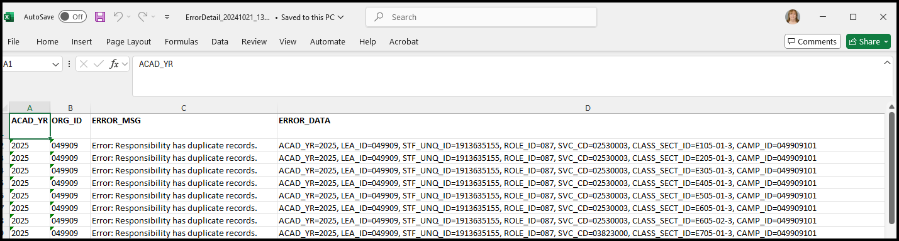

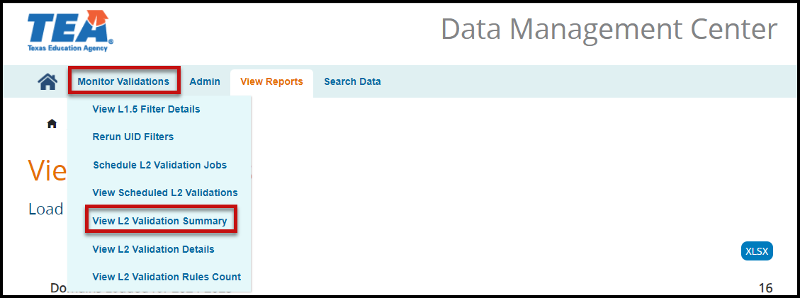

- Under Monitor Validations select View L2 Validation Summary to view the L2 Validation Summary. The View L2 Validation Summary screen appears.

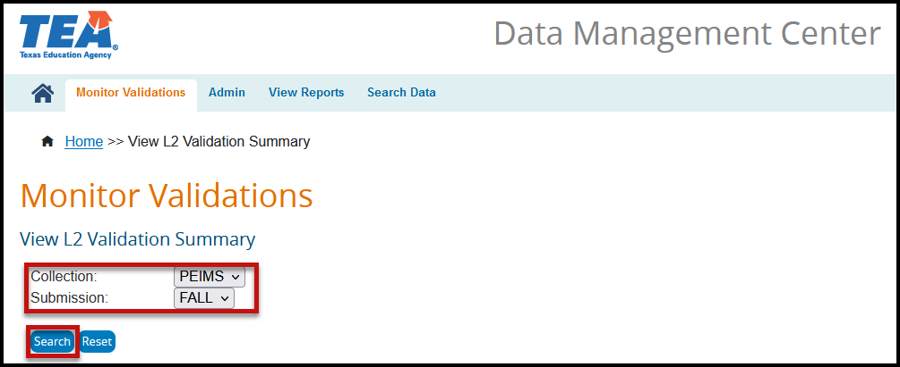

- Select PEIMS from the Collection pull-down menu.
- Select FALL from the Submission pull-down menu.
- Click Search. The Summary screen appears listing the Collection, Submission, Category, Subcategory, Last Successful Run (DTS), Details, number of F(atals), S(pecial Warnings), and W(arnings).

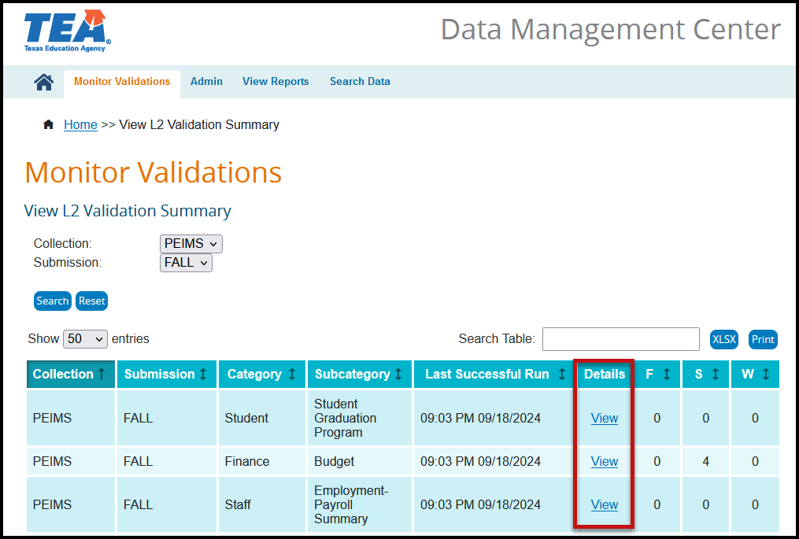

- The number of entries shown can be changed using the pull-down menu for Show entries.
- Items on the table can be searched using the Search Table feature.
- The errors can be viewed by selecting the View hyperlink.
- The data can be Printed or downloaded as an XLSX.

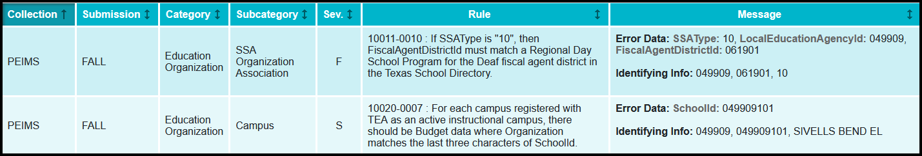

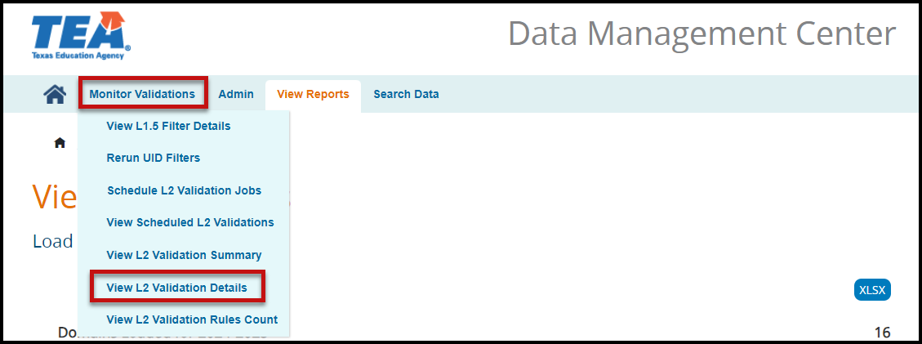

- Under Monitor Validations select View L2 Validation Details to view the L2 Validation error Details. The View L2 Validation Details screen appears.

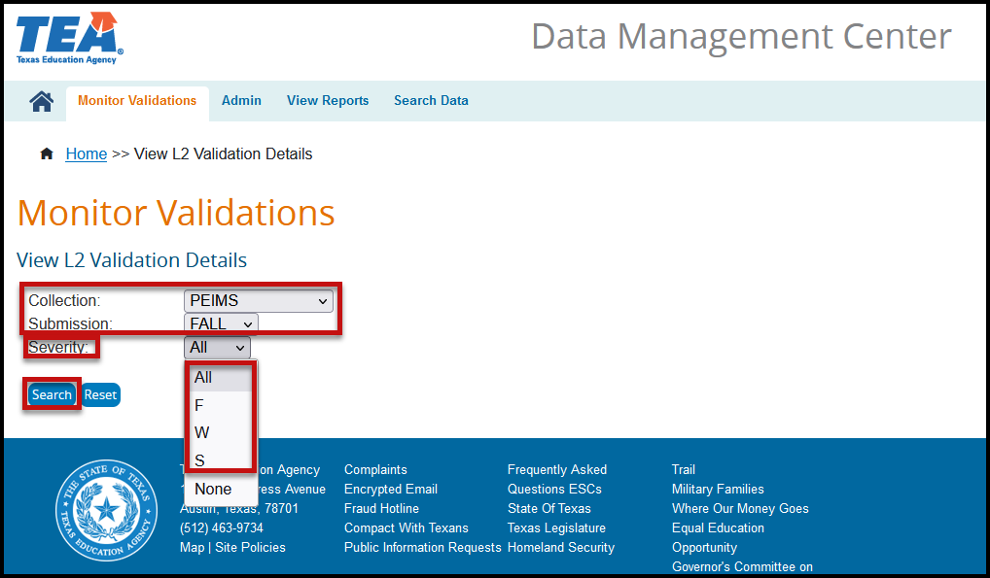

- Select PEIMS from the Collection pull-down menu.
- Select FALL from the Submission pull-down menu.
- Select the Severity from the pull-down menu.
- Click Search. A screen will appear with the selected Error Details.

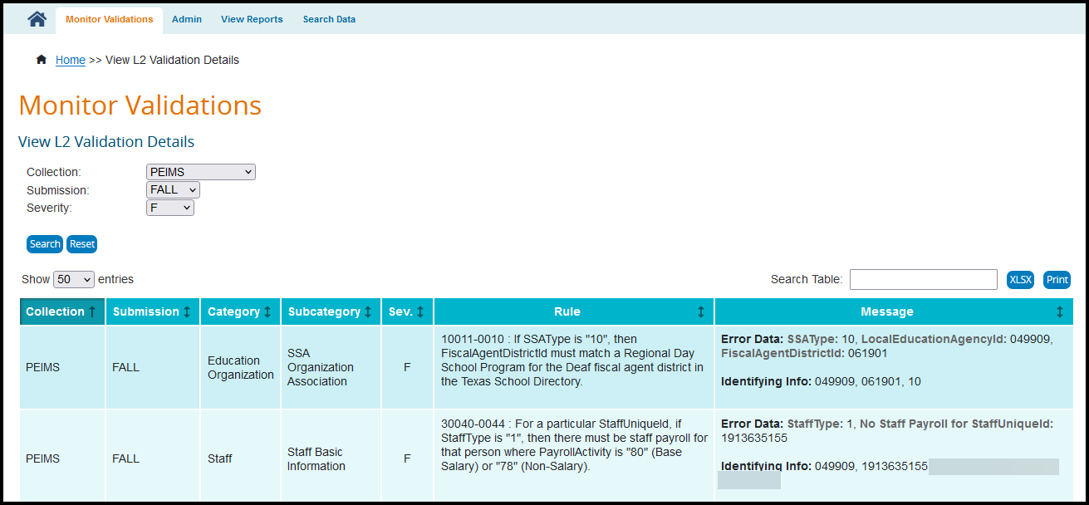

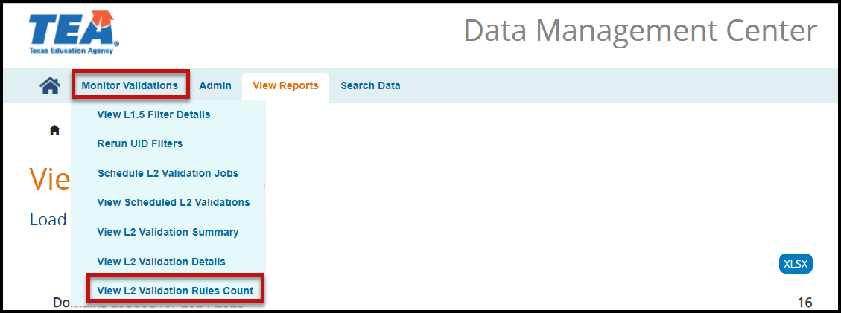

- Under Monitor Validations select View L2 Validation Rules Count to view the L2 Validation errors by count, no details. The Count L2 Validation Rules screen appears

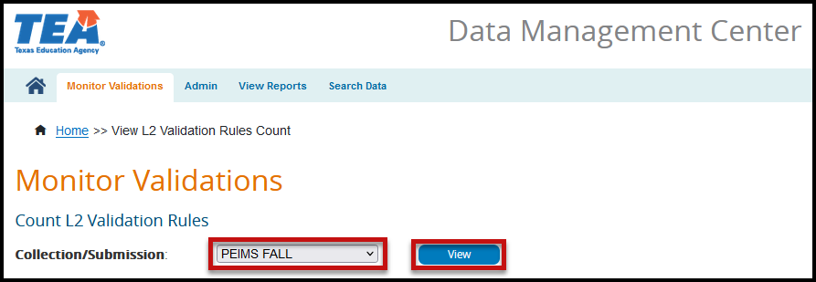

- Select PEIMS FALL from the Collection/Submission pull-down menu.
- Click View. A list of errors by error number, description, and count appears.

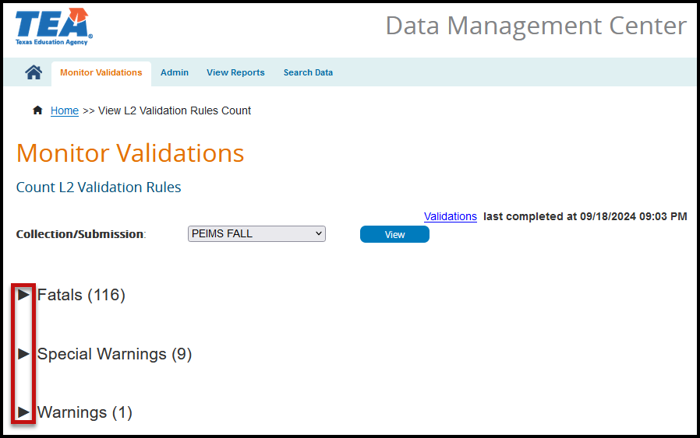

- Click the arrow next to the error type to view. A screen appears with the RuleNumber, RuleDescription, and the Count.
- Click the Validations hyperlink to return to the Validations screen.

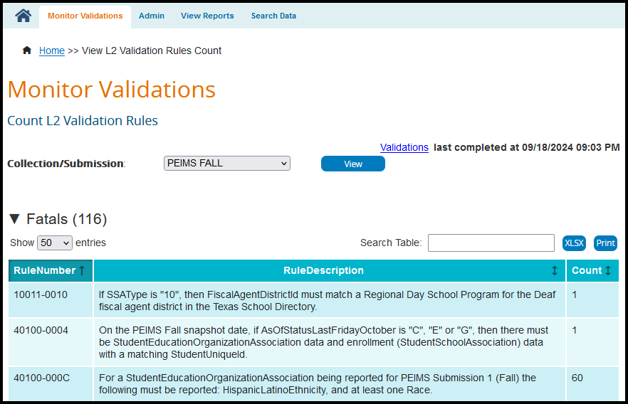

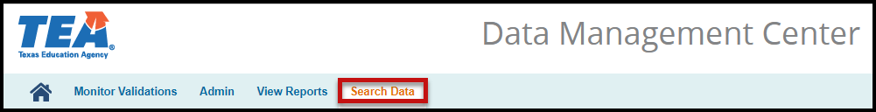

- From the menu bar, select Search Data. The Search Landing Zone (IODS) screen appears.

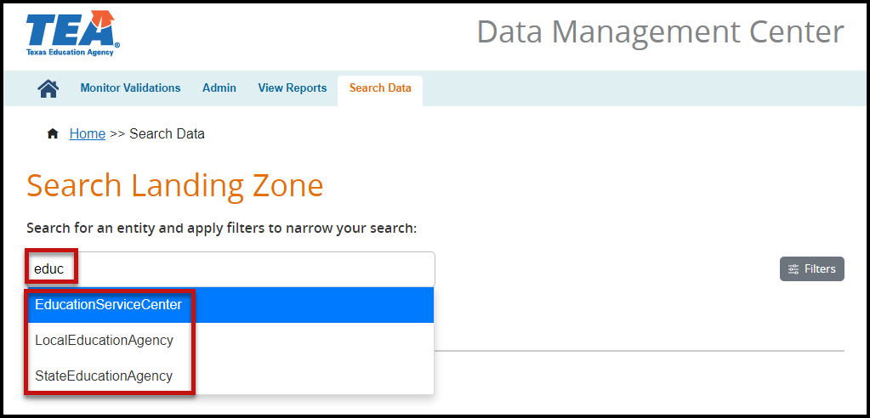

- Enter the name of the entity you are searching for.

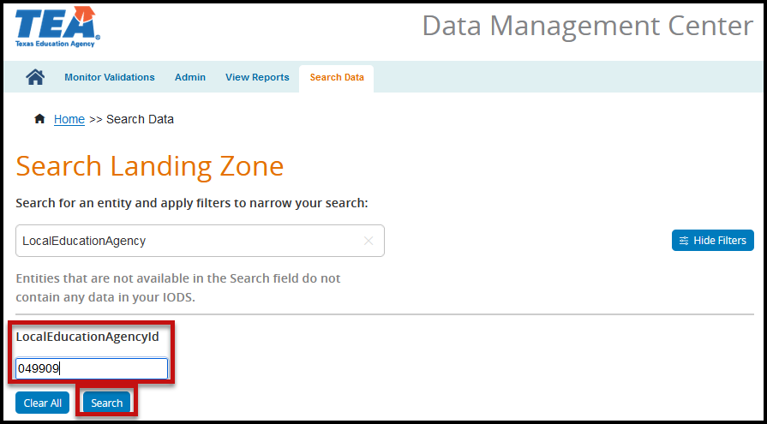

- Enter the information for the filter(s).
- Click Search. A table appears with an option to View the JSON (IODS) data.
- Click View to view the data in the IODS in TSDS Ed-Fi format.

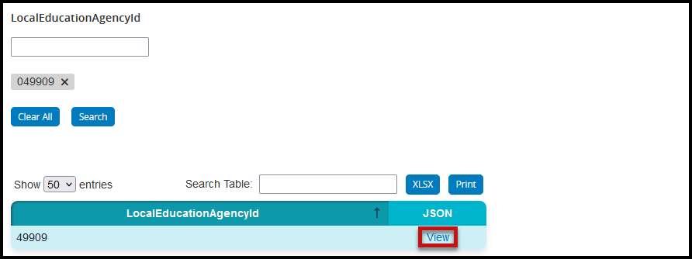

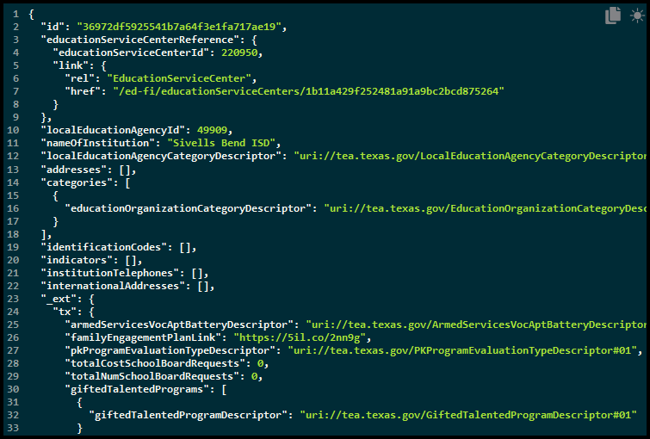

Promoting PEIMS files – TSDS PEIMS Promote Loaded Data

The eDM Promote Loaded Data tool allows users to promote data that has been loaded and batched.

- Log in to TEAL and select Texas Student Data System Portal.
- On the Home screen select PEIMS>Promote Loaded Data.
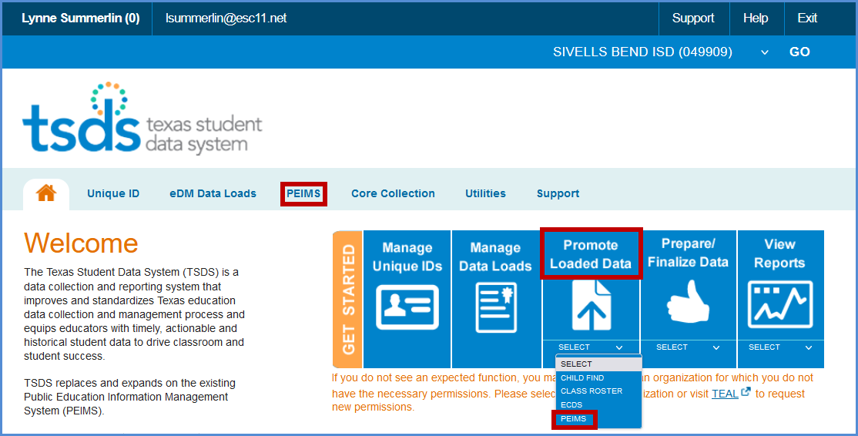
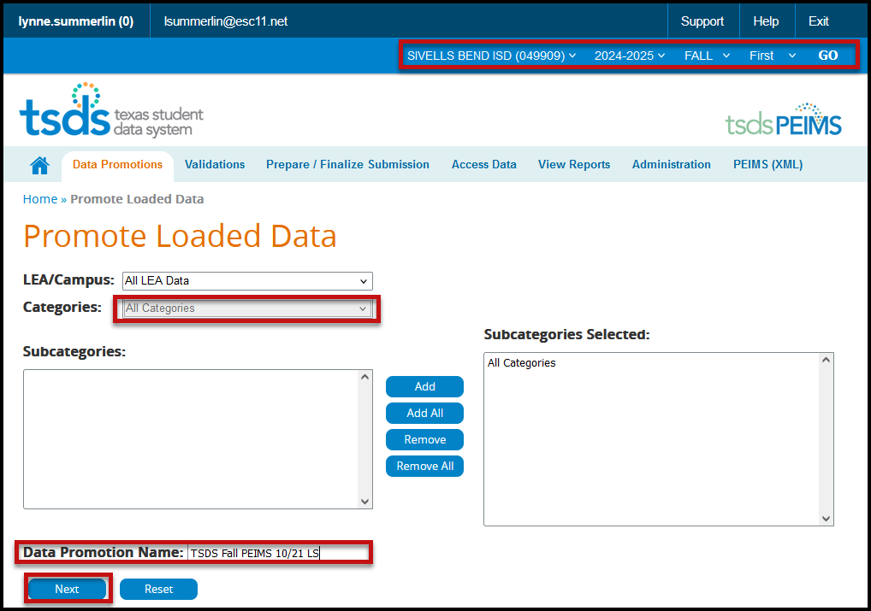
- The Promote Loaded Data screen appears:

- Verify the correct submission is selected. If not, select it from the pull-down menu and click GO.
- From the Categories pull-down menu, select All Categories or the Individual Categories to be promoted. If individual categories are selected user may also select individual subcategories.
- Enter a Data Promotion Name.
- Click Next to continue or Reset to clear selections.
- The Confirm Data Promotion screen appears:

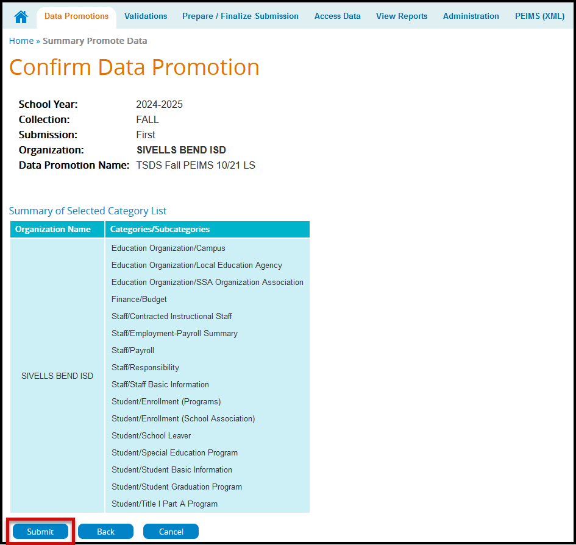
- Verify the Categories/Subcategories.
- Click Submit, Cancel, or Back.
- The Monitor Data Promotions screen appears:

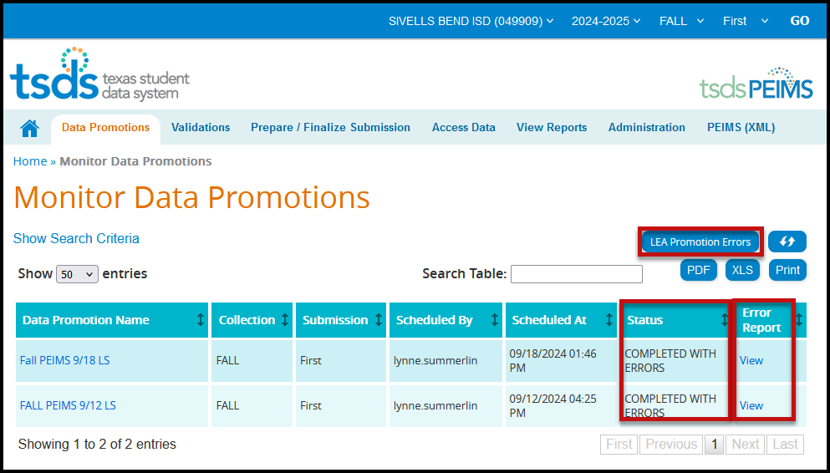

- This screen shows the status of the data promotion, promotion error reports, and a confirmation message that the data was promoted.
- To view promotion errors, click the View link under Error Report or click the LEA Promotion Errors button.
- The LEA Data Promotion Errors screen appears:

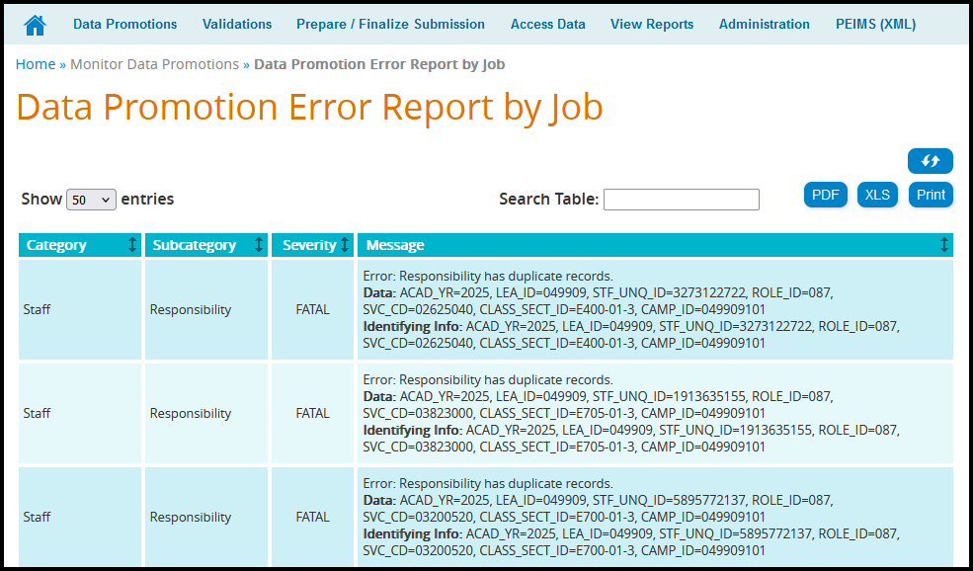

- This screen will list any errors by Category, Subcategory, Severity, along with the error message. Errors can be saved as a PDF or XLS file or can be printed by selecting the appropriate button.

Validating PEIMS files – TSDS PEIMS Promote Loaded Data>Validations

This process allows users to validate data that has been promoted in TSDS. This is where the district will be able to view the Fatals, Warnings, and Special Warnings for the submission.

- Log in to TEAL and select Texas Student Data System Portal.
- On the Home screen select Promote Loaded Data. Select the Validations tab>Validate Submission Data.

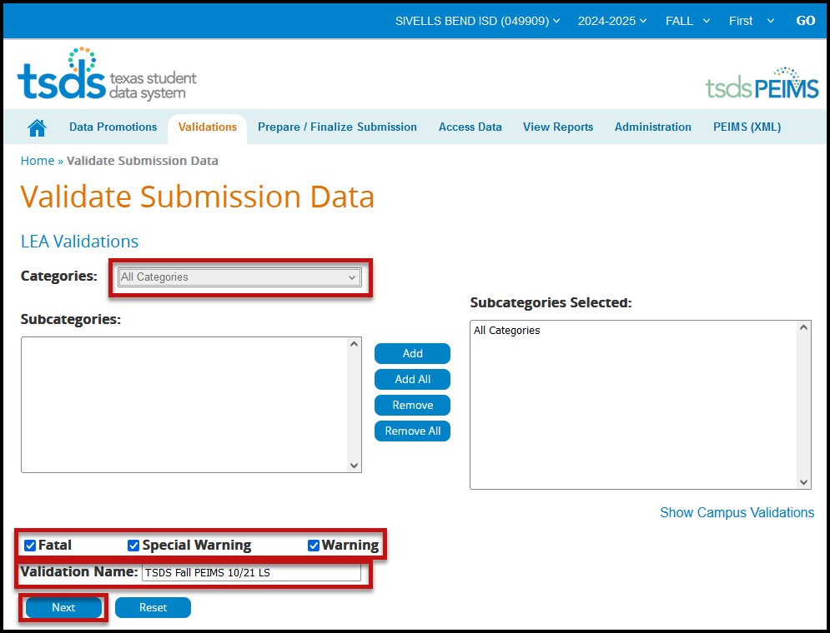

- From the Categories pull-down menu, select All Categories or the individual categories that are to be validated.
- Select the type of validation (Fatal, Warning, Special Warning).
- Enter a Validation Name.
- Click Next to continue the process or Reset to clear all options.
- The Confirm Data Validation screen appears:
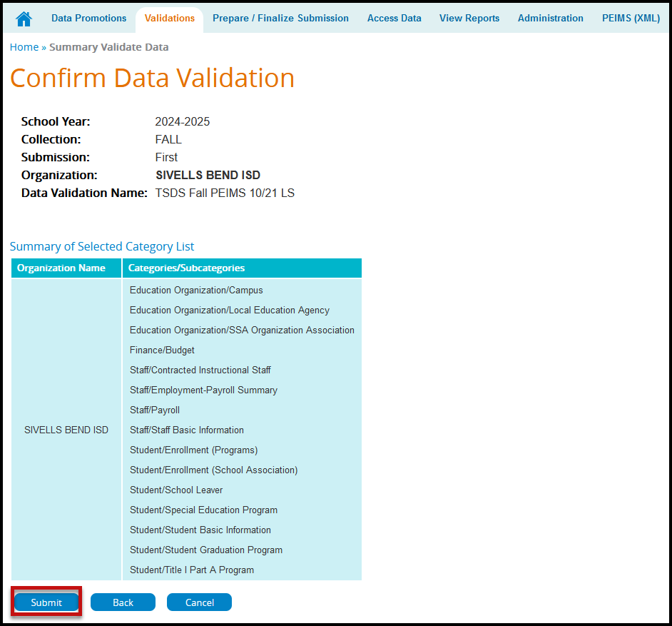
- Verify the Categories/Subcategories.
- Click Submit, Cancel, or Back.
- The Monitor Data Validations screen appears:

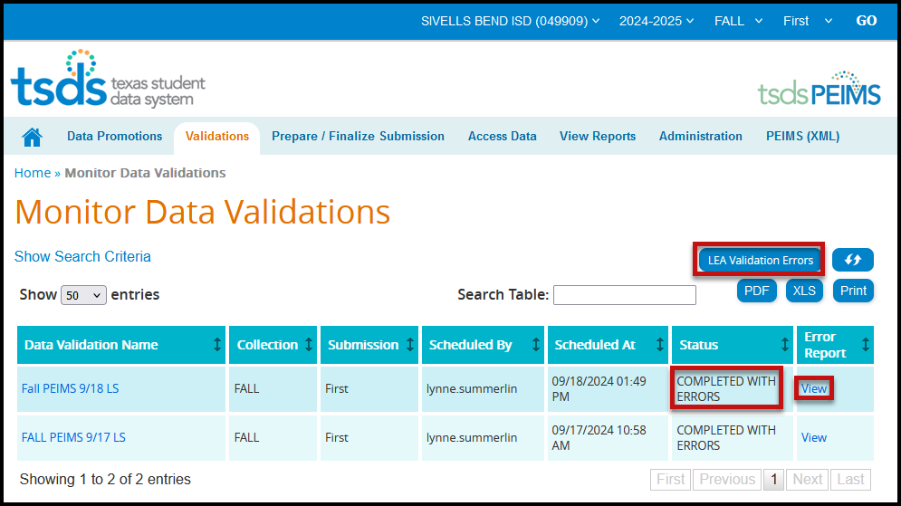

- This screen shows the status of the data validations, validation error reports, and a confirmation message that the data has been submitted.
- To view validation errors by job, click the LEA Validation Errors button or View under Error Report.

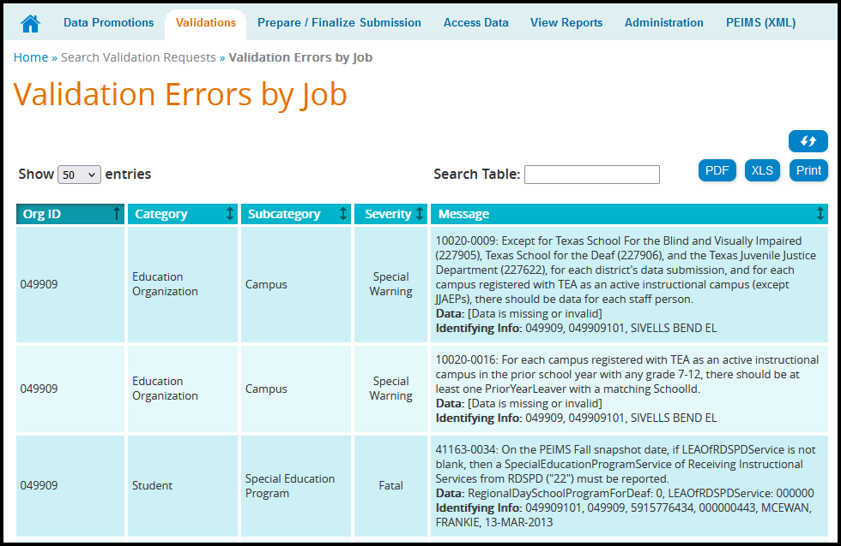

- This screen will list any errors by Category, Subcategory, Severity, along with the error message.
- Errors can be sorted by individual columns. The errors can also be saved as a PDF or XLS file or can be printed by selecting the appropriate button.

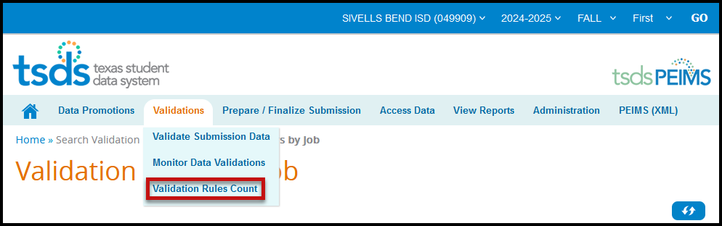
- To view errors by severity (Fatal, Special Warning, and Warning) select Validation Rules Count from the Validations pull-down.

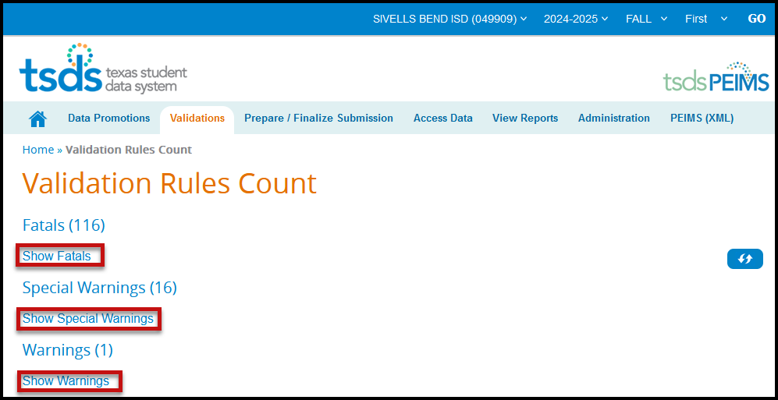
- Click on the “Show” link to view errors.

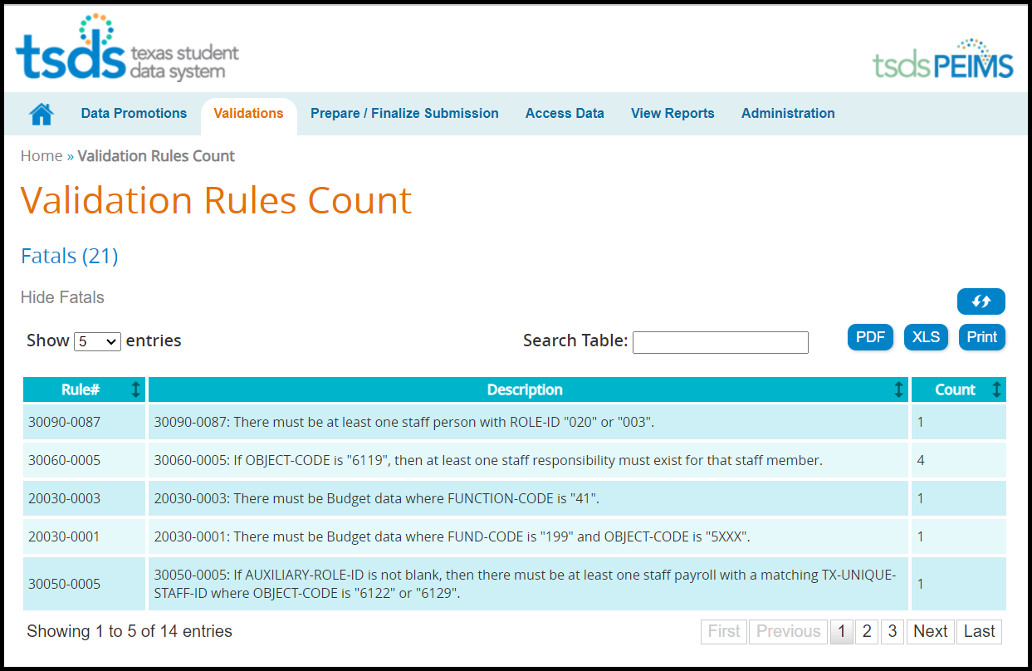

- Correct any fatals. Verify or correct any warnings or special warnings in the database, re-extract the data, and process again through TSDS.

TSDS – Search Data - TSDS PEIMS Promote Loaded Data>Access Data

To access the data or student rosters, click on the Access Data tab and select either Search Submission Data or Search Student Roster.

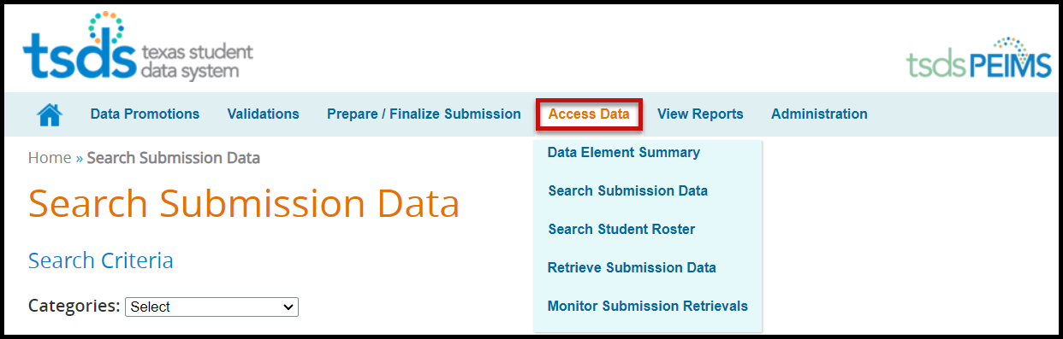

Accessing PEIMS data using Search Submission Data

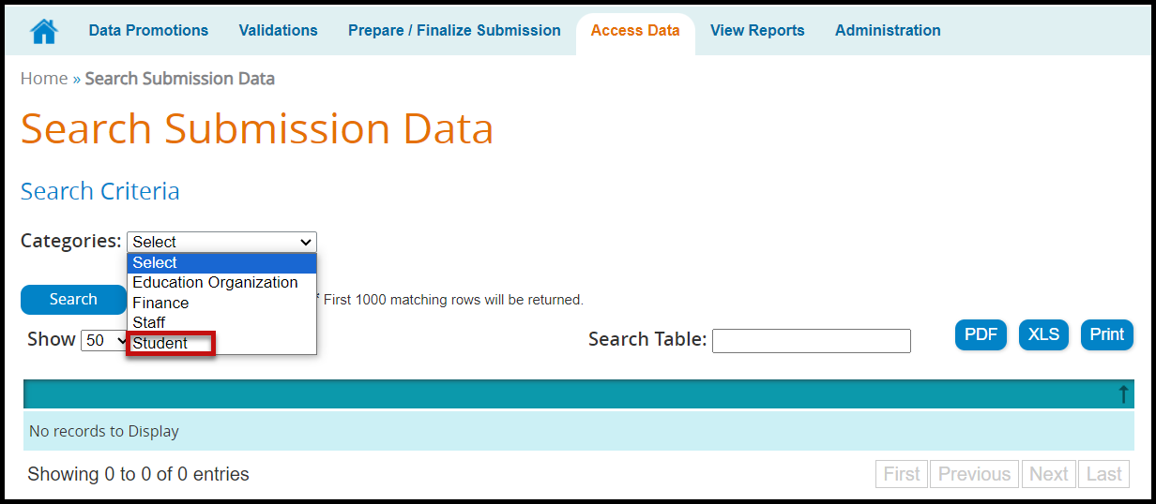

- On the Search Submission Data screen, select the search category from the Categories pull-down menu. The Subcategories field appears:

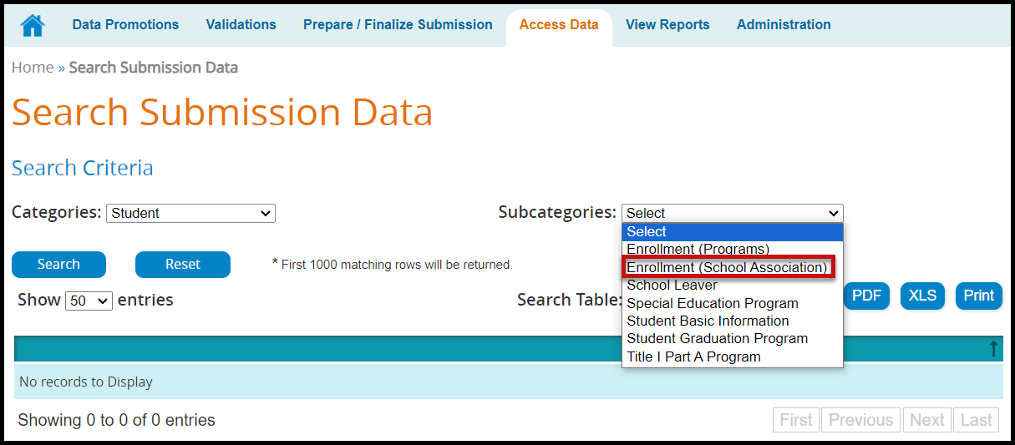

- Select a Subcategory from the pull-down menu if required. Once selected, additional fields appear based on the original category and subcategory selected. At least one required field (*) must be entered to complete the search.

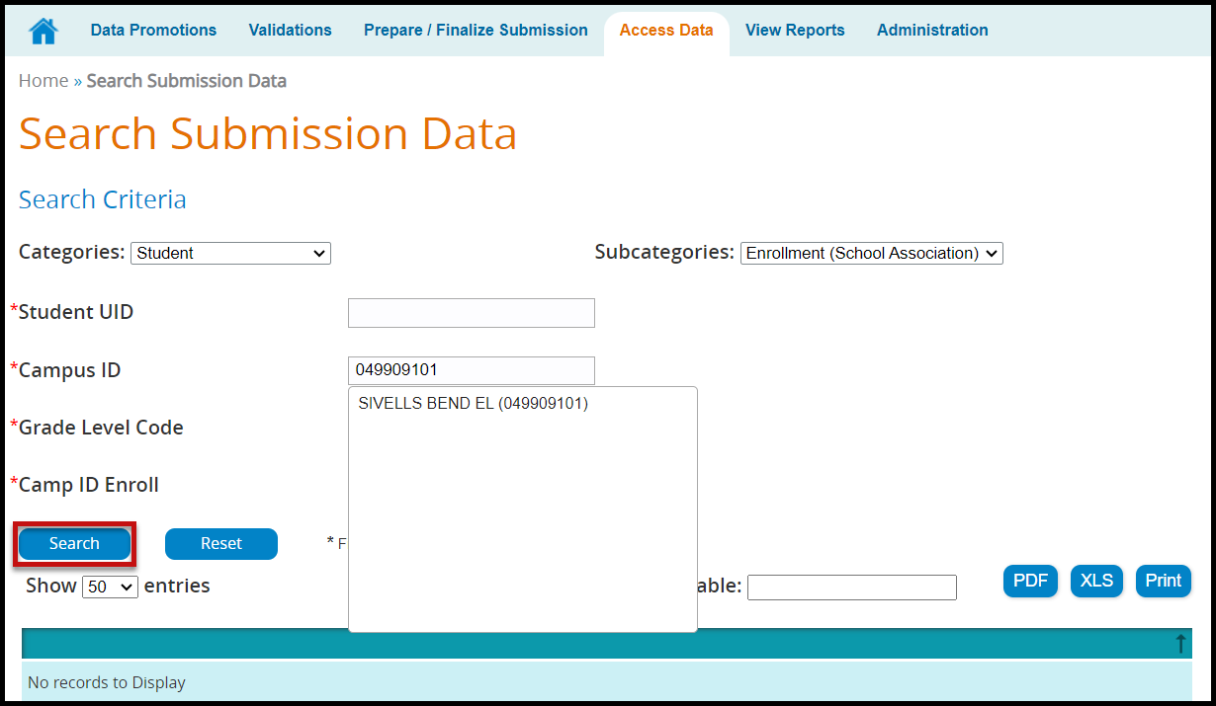
- Click Search to view data matching entered criteria or click Reset to clear selected criteria.

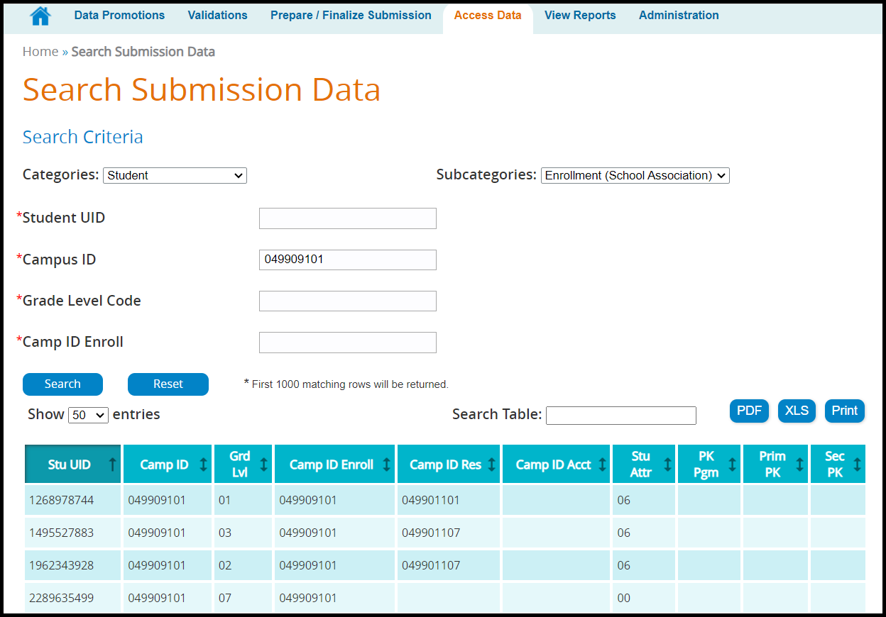

- Show entries allows the user to select up to 500 entries to view at a time.
- The Search Table field allows the user to filter the search by fields. An example would be to search for only 8th grade (enter 08 in the field).
- The search results can be Printed, saved/printed as a PDF or XLS.
- The search results can be sorted by the individual columns by clicking on the column header.

Accessing PEIMS data using Search Student Roster

This search allows districts to search the student roster for specific student data. It is used to help districts with their Leaver data.

- Enter search criteria. Any field with a red asterisk (*) is a required field. At least one required field must be selected to search.

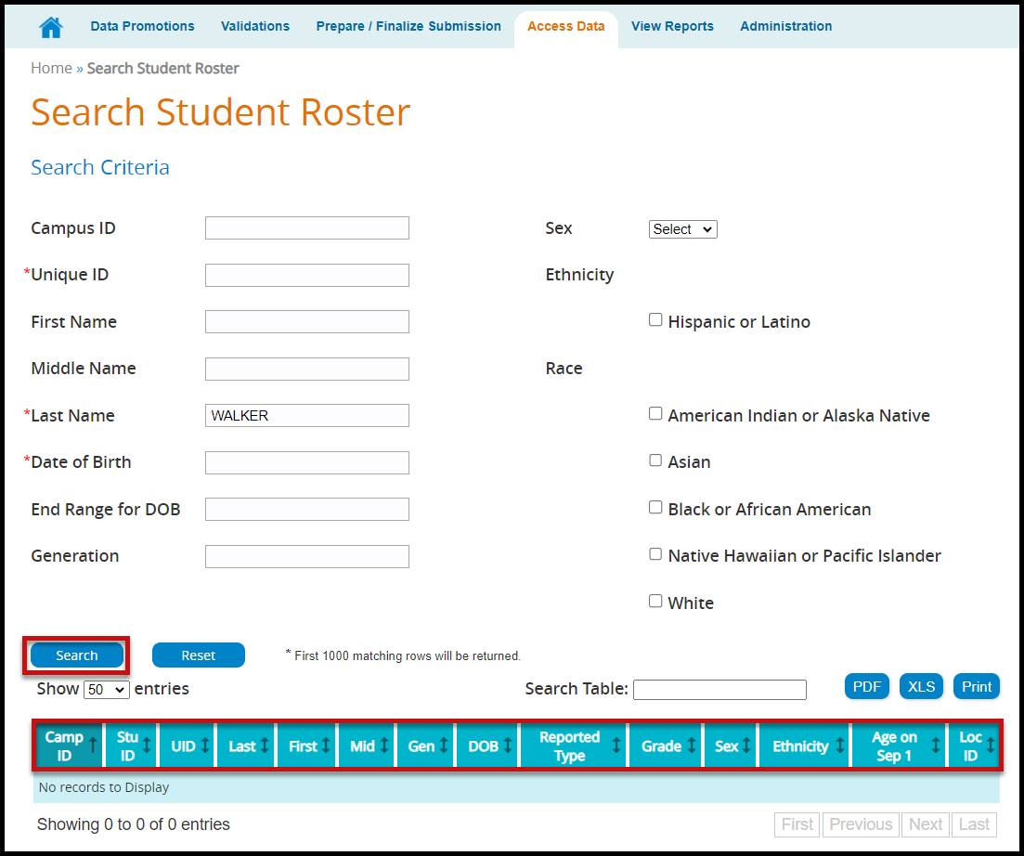

TSDS – PEIMS View Reports

Reports must be run and verified prior to and after completing and accepting the PEIMS data submission. These reports are the same as the reports in Edit+ and must be compared for accuracy of the submission. The TSDS PEIMS reports are separated into three categories:

- Standard Reports – These reports are available at any time and reflect the current data loaded into PEIMS, whether the collection has been completed or not.
- Special Reports – These reports are summary reports that help completers, approvers, and accepters review the data submission. These reports also are available at any time and reflect the current data loaded into PEIMS, whether the collection has been completed or not.
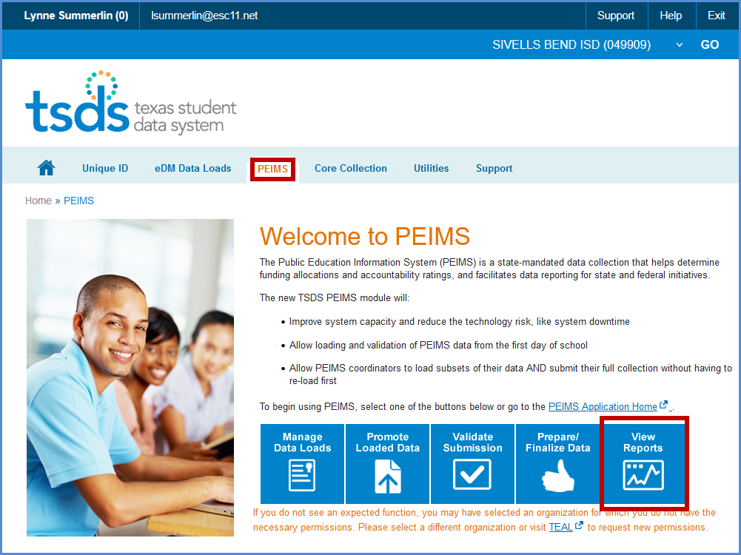
- Student Leaver Reports – These are the individual LEA reports that use data from across the state to help districts identify their leavers. These reports are only in each submission after the submission has closed and TEA has calculated the leavers. These reports only reflect finalized data.
- UID Discrepancies – These reports are used to identify discrepancies between Unique ID data and PEIMS Demographic data.
- Bundled Reports – These are reports that are generated together for ease of downloading.

To access the reports:

- Log in to TEAL and select Texas Student Data System Portal.
- On the Home screen select View Reports. Select the View Reports tab.

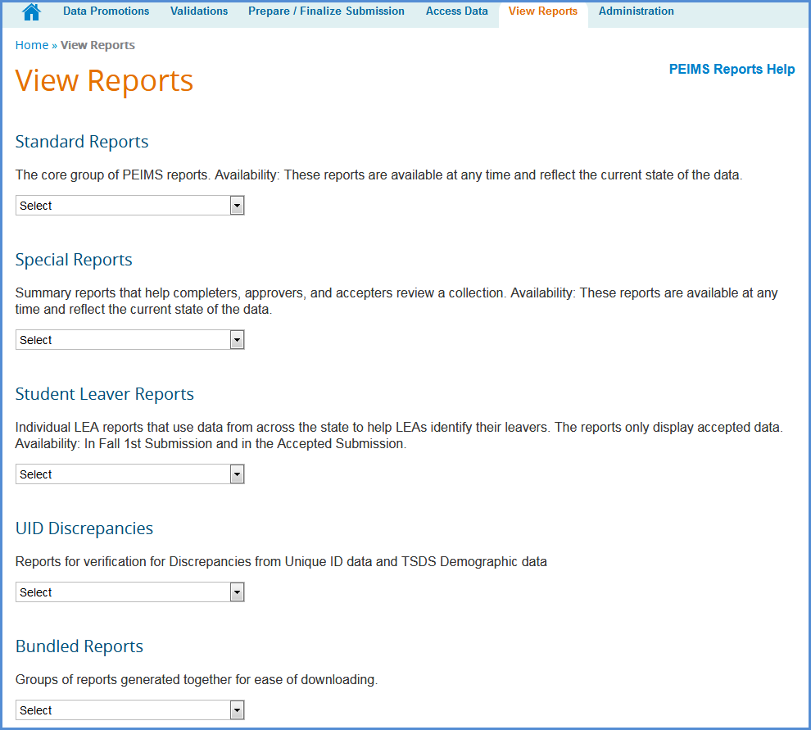
Under View Reports, select from the pull-down menu the report to run in the appropriate category.
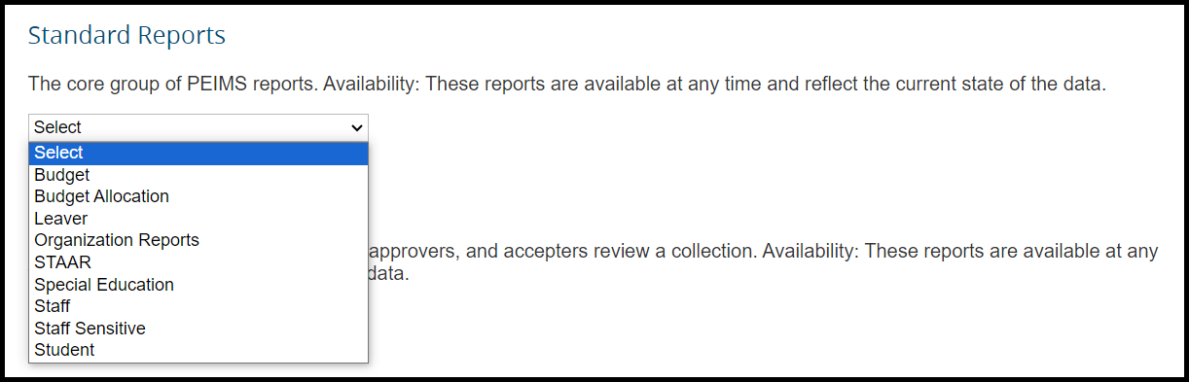

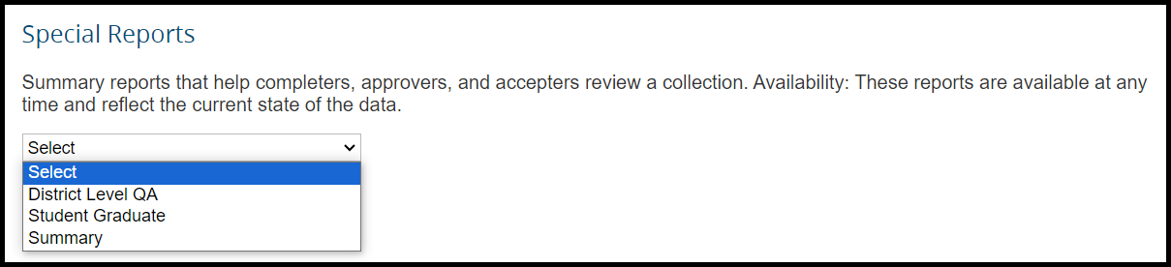
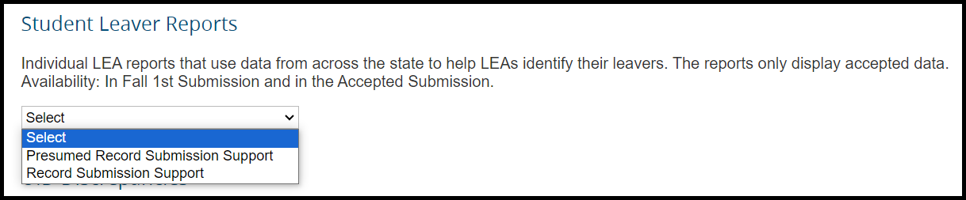
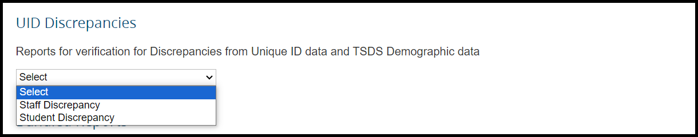

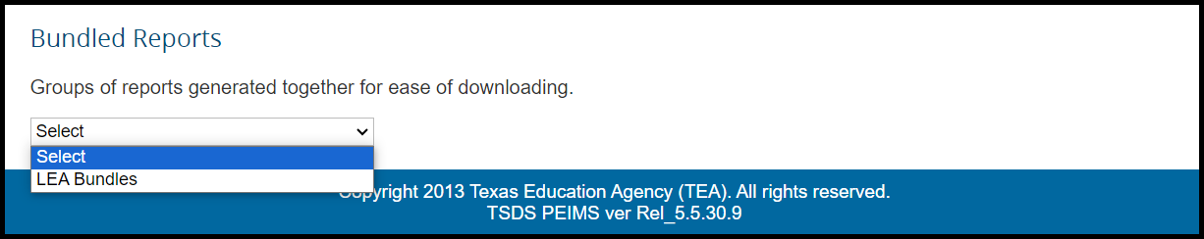

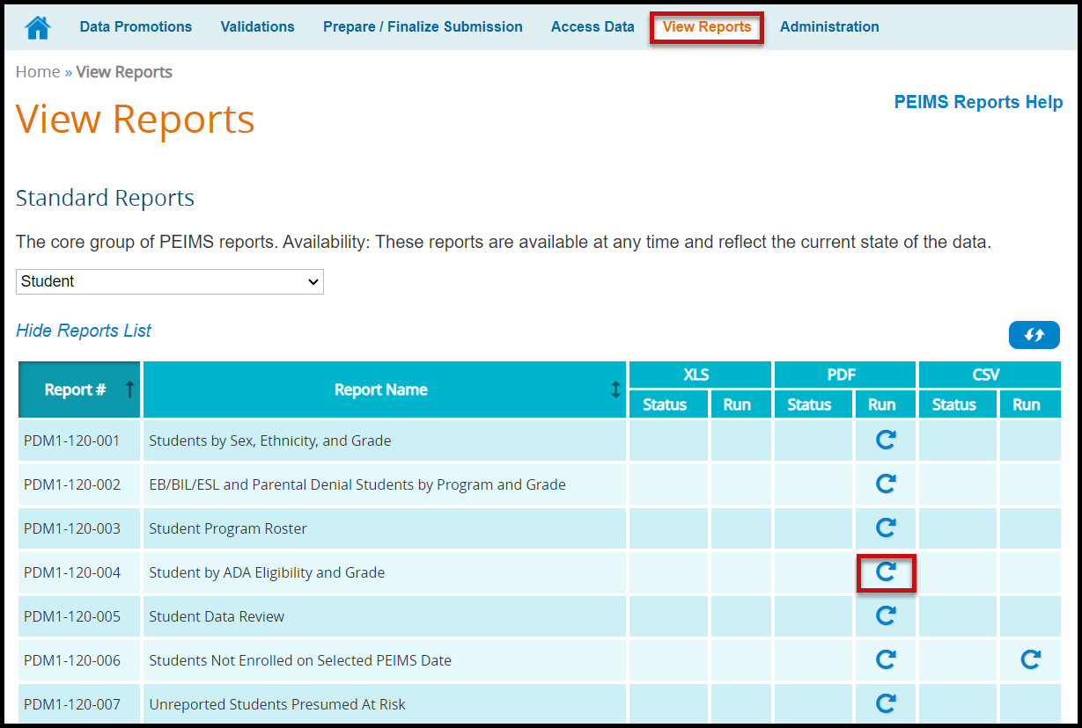

- Click the circular arrow under Run. The Report Parameters screen appears:
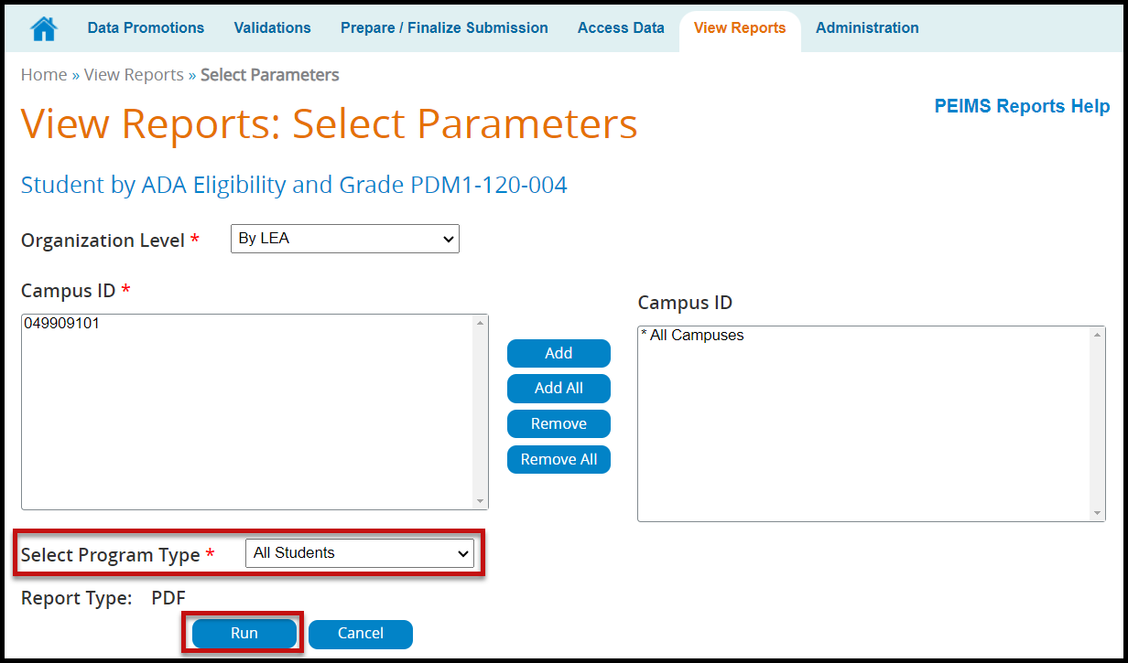

- Reports can be run by district or campus by changing the Organization Level selection.
- Select the appropriate parameters and click Run. The View Reports page appears showing the status of the report. The reports are associated to the individual user to prevent other users from overwriting the reports.

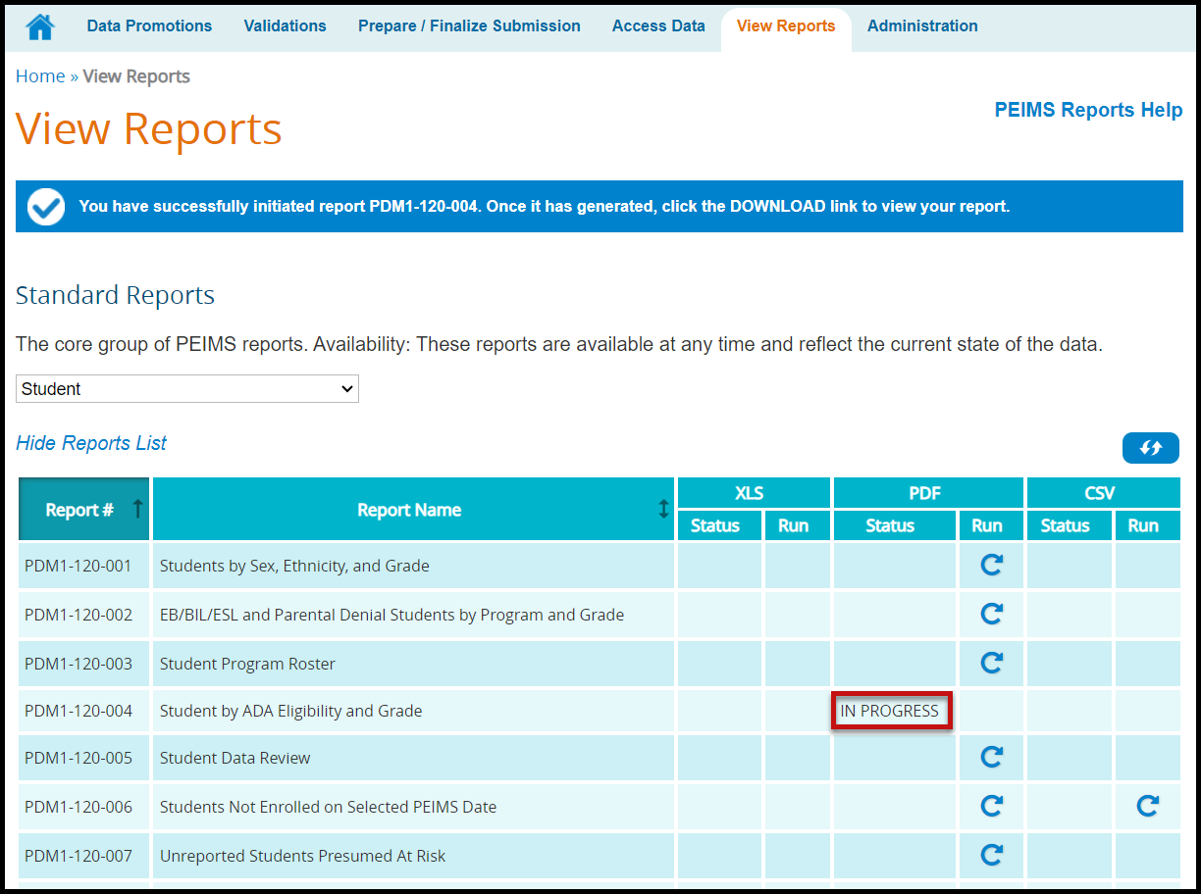

- Once the report is complete a hyperlink will appear, allowing the report to be downloaded.

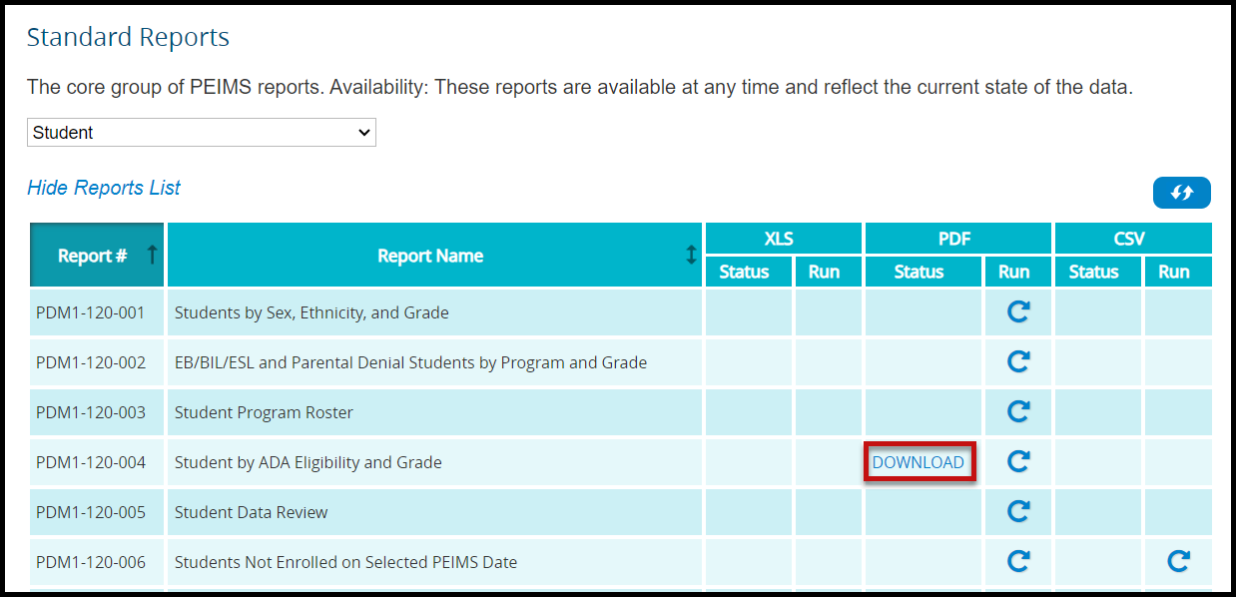

TSDS – PEIMS Prepare/Finalize Process (Sample Screenshots)

Once data has been validated, the district will prepare and finalize the data which will include completing the process so that the ESC PEIMS coordinator can verify the submission. From this screen the district PEIMS Data Completer can lock categories once the categories are fatal free to prevent the data being overwritten.

- Log in to TEAL and select Texas Student Data System Portal.
- On the Home screen select Prepare/Finalize Data.
- Verify that PEIMS is selected from the pull-down menu (if applicable).

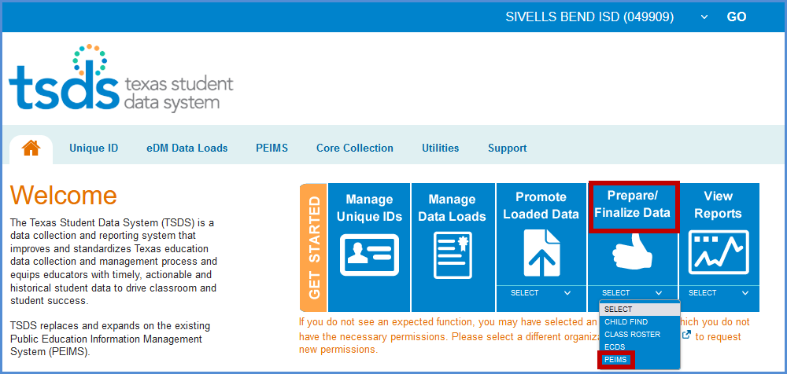

- Verify the correct collection has been selected.
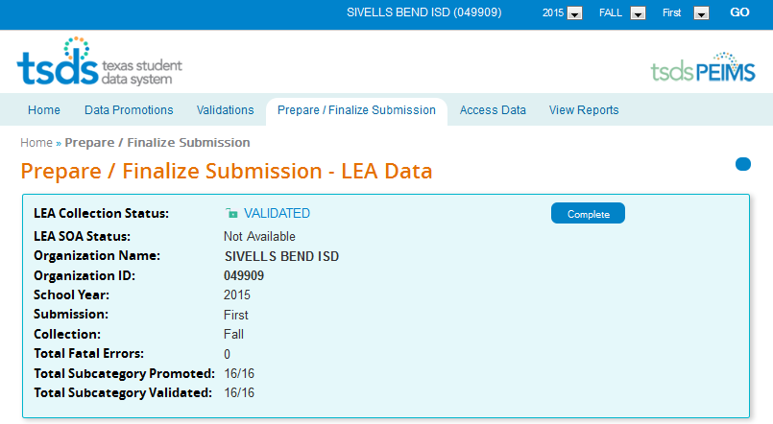

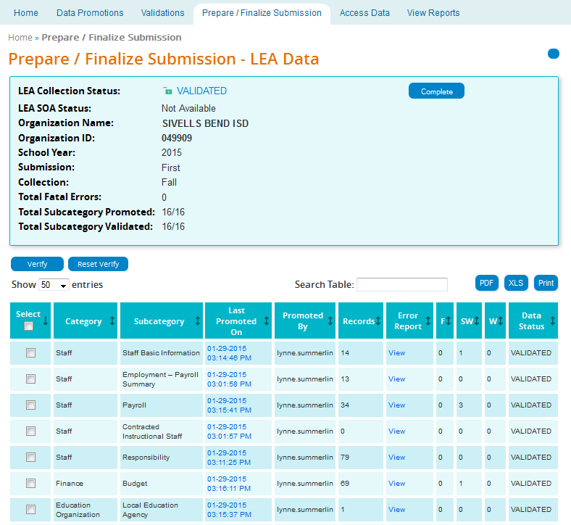

- This screen shows records by Category and Subcategory.
- In the Last Promoted On column is the time date stamp for the last time the data was promoted to PEIMS.
- Promoted By lists the user name of the person that last promoted the data.
- The number of records for the Category/Subcategory is listed in the Records column.
- Click View in the Error Report field to view the Fatal, Special, and Warning errors for a particular Category/Subcategory.
- The number of errors by Category/Subcategory are listed under the columns labeled:

- F (Fatal)
- SW (Special Warning)
- W (Warning)

- The current status (Promoted, Validated, etc.) of the Category/Subcategory is listed under the column Data Status.
- The data on the screen can be saved/printed in PDF or XLS by clicking on the appropriate button.
- A search can be done on the screen by using the Search field.
- To verify or “lock” data, the category/subcategory must have a Data Status of Validated. Click the checkbox adjacent to the Category/Subcategory that needs to be verified and click Verify.
- To “unlock” data, click the checkbox adjacent to the Category/Subcategory that needs to be unlocked and click Reset Verify.

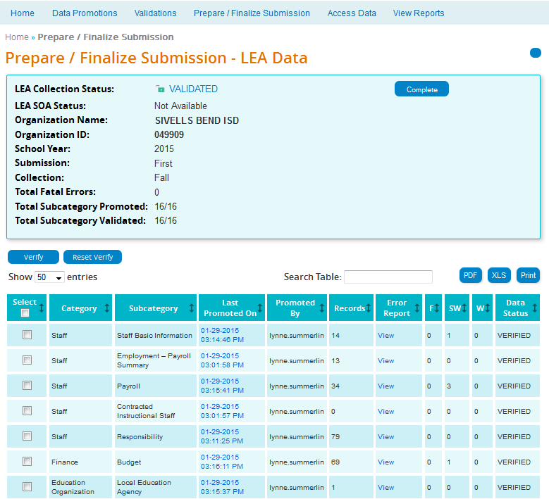

- The PEIMS Data Completer can click the Complete button to complete the file so the ESC can verify data. All files must be fatal free in order to complete the files. The Completion Process Status bar appears:

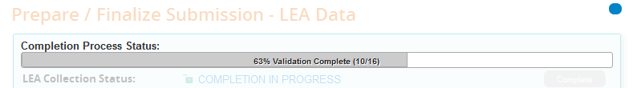

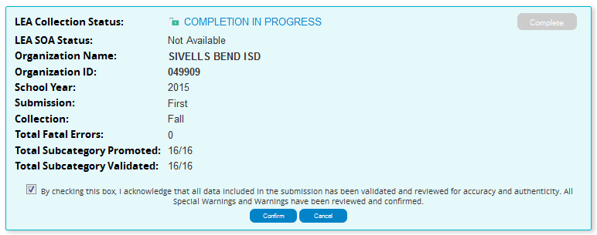
- Once validation process is complete, check the checkbox acknowledging the submission have been validated and reviewed for accuracy and authenticity and that all warnings and special warnings have been reviewed and confirmed.
- Click the Confirm button and the data is now ready for the ESC to verify and accept or reject.
- If rejected the district must correct the data and go through the whole process again.

TSDS – Superintendent Approval Form (SAF) Process

The Superintendent must approve all PEIMS submissions. This is accomplished through the Superintendent Approval Form (SAF) process. The Superintendent may also request an extension for one of the PEIMS submissions. All extensions must be approved by TEA. The district must have extenuating circumstances to receive an extension.

ESC Region 11 grants permission to attendees of this session to reproduce and distribute designated resources and materials provided during the presentation.

